**FAST**

**National University of Computer and Emerging Sciences**



**Web Programming**

**Lab #3**

**Submitted by:**

**Rimsha Sarfraz(21F-9244)**

**BSCS_6E**

**Submitted to: Mam Sumaira Mustafa**

**Dated: 15th Feb ,2024**

Task 1:

**Code:**

<!DOCTYPE html>

<html lang="en">

<head>

<meta charset="UTF-8">

<meta http-equiv="X-UA-Compatible" content="IE=edge">

<meta name="viewport" content="width=device-width, initial-scale=1.0">

<title>CSS Exercise</title>

<style>

body {

font-family: Arial, sans-serif;

margin: 0;

padding: 0;

box-sizing: border-box;

background-color: #f0f0f0;

}

header {

background-color: #333;

color: #fff;

text-align: center;

padding: 1rem 0;

}

main {

text-align: center;

margin-top: 2rem;

}

p {

font-size: 1.2rem;

margin-bottom: 1rem;

}

.button {

display: inline-block;

padding: 1rem 3rem;

background-color: #181717;

color: #fff;

text-decoration: none;

border-radius: 5px;

transition: background-color 0.3s;

}

.button:hover {

background-color: #555;

}

</style>

</head>

<body>

<header>

<h1>Start CSS Exercises</h1>

</header>

<main>

<p>Good luck!</p>

<a href="https://www.w3schools.com" class="button">CSS Exercises ></a>

</main>

</body>

</html>

**Output:**

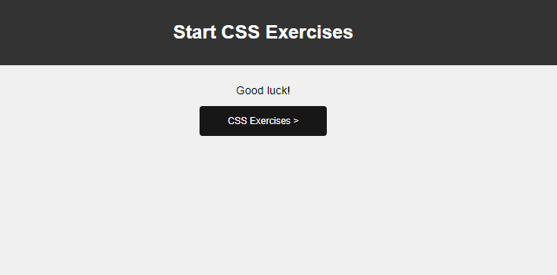

Task 2:

**Code:**

<!DOCTYPE html>

<html lang="en">

<head>

<meta charset="UTF-8">

<meta http-equiv="X-UA-Compatible" content="IE=edge">

<meta name="viewport" content="width=device-width, initial-scale=1.0">

<title>Registration Form of Fast NU</title>

<style>

body {

font-family: Arial, sans-serif;

margin: 0;

padding: 0;

box-sizing: border-box;

background-color: #f8f8f8;

color: #ffffff;

display: flex;

justify-content: center;

align-items: center;

height: 100vh;

}

form {

width: 300px;

padding: 20px;

background-color: #000000;

border-radius: 5px;

box-shadow: 0 2px 5px rgba(0, 0, 0, 0.1);

}

input[type="text"],

input[type="password"],

input[type="number"],

input[type="email"] {

width: 100%;

padding: 8px;

margin-bottom: 10px;

border: 1px solid #ccc;

border-radius: 5px;

box-sizing: border-box;

}

input[type="submit"] {

width: 100%;

padding: 8px;

background-color: #696969;

color: #fff;

border: none;

border-radius: 5px;

cursor: pointer;

}

input[type="submit"]:hover {

background-color: #464444;

}

</style>

</head>

<body>

<form>

<label for="name">Name:</label>

<input type="text" id="name" name="name" placeholder="Enter your name" required><br>

<label for="username">Username:</label>

<input type="text" id="username" name="username" placeholder="Enter your username" required><br>

<label for="password">Password:</label>

<input type="password" id="password" name="password" placeholder="Enter your password" required><br>

<label for="number">Number:</label>

<input type="number" id="number" name="number" placeholder="Enter your number" required><br>

<label for="email">Email:</label>

<input type="email" id="email" name="email" placeholder="Enter your email" required><br>

<input type="submit" value="Submit">

</form>

</body>

</html>

**Output:**

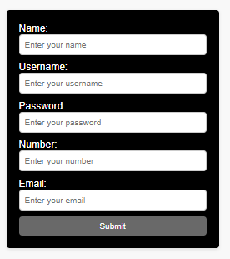

Task 3:

**Code:**

<!DOCTYPE html>

<html lang="en">

<head>

<meta charset="UTF-8">

<meta name="viewport" content="width=device-width, initial-scale=1.0">

<title>Card Example</title>

<style>

.card {

width: 1000px;

border: 1px solid #353434;

border-radius: 5px;

overflow: hidden;

margin: 10px;

background-color: #f9f9f9;

text-align: left;

}

.card img {

width: 100%;

height: auto;

display: block;

}

.card-content {

padding: 15px;

}

.card-content h3 {

margin-top: 0;

}

.card-content p {

margin: 10px 0;

}

.card-content a {

display: inline-block;

padding: 5px 10px;

background-color: #007bff;

color: #fff;

text-decoration: none;

border-radius: 3px;

}

</style>

</head>

<body>

<div class="card">

<img src="card_a.jpg" alt="Image">

<div class="card-content">

<h3>Life Lessons</h3>

<p>Pace Yourself. ...

You Can't Please Everyone. ...

Your Health Is Your Most Valuable Asset. ...

You Don't Always Get What You Want. ...

It's Not All About You. ...</p>

<a href="#">Read more</a>

</div>

</div>

</body>

</html>

**Output:**



Task 4:

**Code:**

<!DOCTYPE html>

<html lang="en">

<head>

<meta charset="UTF-8">

<meta name="viewport" content="width=device-width, initial-scale=1.0">

<title>Card Example</title>

<style>

@keyframes slideIn {

0% {

transform: translateX(-100%);

opacity: 0;

}

100% {

transform: translateX(0);

opacity: 1;

}

}

.card {

width: 1000px;

border: 1px solid #353434;

border-radius: 5px;

overflow: hidden;

margin: 10px;

background-color: #f9f9f9;

text-align: left;

animation: slideIn 1s ease-out 0s 1; /* Animation duration: 1 second */

}

.card img {

width: 100%;

height: auto;

display: block;

}

.card-content {

padding: 15px;

}

.card-content h3 {

margin-top: 0;

}

.card-content p {

margin: 10px 0;

display: block; /* Display the text block */

}

</style>

</head>

<body>

<div class="card">

<img src="card_a.jpg" alt="Image">

<div class="card-content">

<h3>Life Lessons</h3>

<p>Pace Yourself. ...

You Can't Please Everyone. ...

Your Health Is Your Most Valuable Asset. ...

You Don't Always Get What You Want. ...

It's Not All About You. ...</p>

</div>

</div>

</body>

</html>

**Output:**

**After Slidein**

